Device Tracking
Developers often opt to try to track users through the use of permanent hardware identifiers, allowing them to track the user, or users, of a device even if the app is uninstalled and reinstalled. These unique identifiers might include
Mac address
IMEI: International Mobile Equipment Identity (IMEI)[1] is a number, usually unique,[2][3] to identify 3GPP and iDEN mobile phones, as well as some satellite phones. It is usually found printed inside the battery compartment of the phone, but can also be displayed on-screen on most phones by entering *#06#
ESN: Electronic serial numbers (ESNs) were created by the U.S. Federal Communications Commission (FCC) to uniquely identify mobile devices, compared to IMEI, ESNs are often represented as either 11-digit decimal numbers or 8-digit hexadecimal numbers.
MEID: mobile equipment identifier (MEID) is a globally unique number identifying a physical piece of CDMA2000 mobile station equipment. The number format is defined by the 3GPP2 report S.R0048, but in practical terms, it can be seen as an IMEI but with hexadecimal digits.
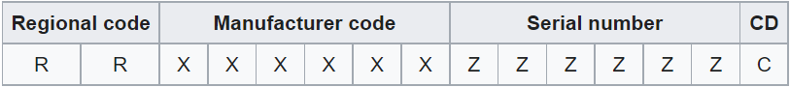
IMSI: The international mobile subscriber identity, The IMSI is used in any mobile network that interconnects with other networks. For GSM, UMTS and LTE networks, this number was provisioned in the SIM card and for cdmaOne and CDMA2000 networks, in the phone directly or in the R-UIM card (the CDMA equivalent of the SIM card). Both cards have been superseded by the UICC.
Serial Number: A hardware serial number, if available. Alphanumeric only, case insensitive. Root access may allow you to modify device identifiers, such as the hardware serial number. If you change these identifiers, you can use key attestation to obtain proof of the device's original identifiers.
*Requires android.Manifest.permission.READ_PRIVILEGED_PHONE_STATE*
ANDROID ID: On Android 8.0 (API level 26) and higher versions of the platform, a 64-bit number (expressed as a hexadecimal string), unique to each combination of app-signing key, user, and device. Values of ANDROID_ID are scoped by signing key and user. The value may change if a factory reset is performed on the device or if an APK signing key changes.

